EMF measurement

User Interface
1) Temperature:
To change the temperature, (0 to 100)
2) Cathode:
Here, the user can change electrode and concentration of the solution.
3) Anode:
Here, the user can change electrode and concentration of the solution.
The volt meter will show the emf according to user changes.
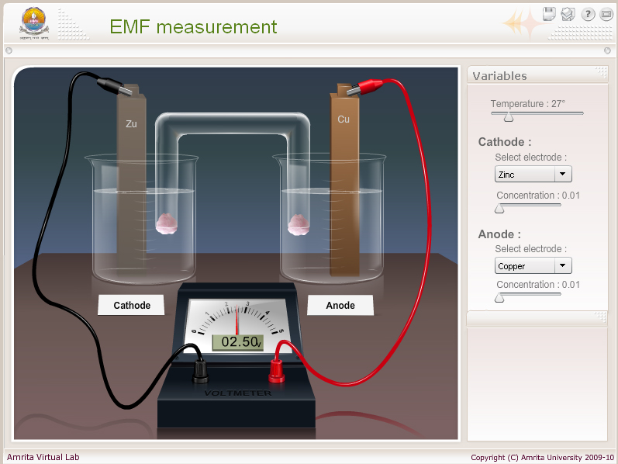

Metals for cathode and anode electrolytes.
Electrode | Electrode potential | c
Li⁺/ Li | -3.04 | 1
K⁺/K | -2.92 | 1
Ba²⁺/Ba | -2.90 | 2
Ca²⁺/Ca | -2.87 | 2
Na⁺/Na | -2.71 | 1
Mg²⁺/Mg | -2.52 | 2
Al³⁺/Al | -1.66 | 3
Mn²⁺/Mn | -1.88 | 2
Zn²⁺/Zn | -0.76 | 2
Cr³⁺/Cr | -0.74 | 3
Fe²⁺/Fe | -0.44 | 2
Cd²⁺/Cd | -0.40 | 2
Tl⁺/Tl | -0.34 | 1
Co²⁺/Co | -0.27 | 2
Ni²⁺/Ni | -0.24 | 2
Sn²⁺/Sn | -0.15 | 2
Pb²⁺/Pb | -0.13 | 2
2H⁺/H₂ | 0.00 | 1
Cu²⁺/Cu | 0.34 | 2
Ag⁺/Ag | +0.80 | 1
Au⁺/Au | +1.50 | 1
Nernst equation
E_{cell} = E⁰ _{cell} – 2.303RT * log[ C^{a+}]^{c}
nF [A^{c+}]ª
E⁰ _{cell} = E⁰ _{cathode} - E⁰ _{anode}
n=c if c=a
n=c×a if c≠a
R= 8.314, T=temperature, F= 96500

